02.50 CONSIDERATION OF ASSURANCE REPORT

The following describes the functionality and features included in Probe Audit Premium+

Objective

The objective of this document is to determine the type of audit opinion to be expressed, to review the draft audit report against the requirements of ISA 700, and to evaluate the reporting of key audit matters in accordance with ISA 701.

The following key concepts of the Probe Audit Premium+ Methodology are set in this document:
- Formation of the audit opinion on the financial statements (ISA 700)
- Systematic evaluation of qualifying conditions that may require a modified opinion (ISA 705)
- Determination of the final form and content of the audit report, including emphasis of matter and other matter paragraphs

Document placement

Document 02.50 – Consideration of assurance report can be found in the Finalisation folder in the Caseware document manager.
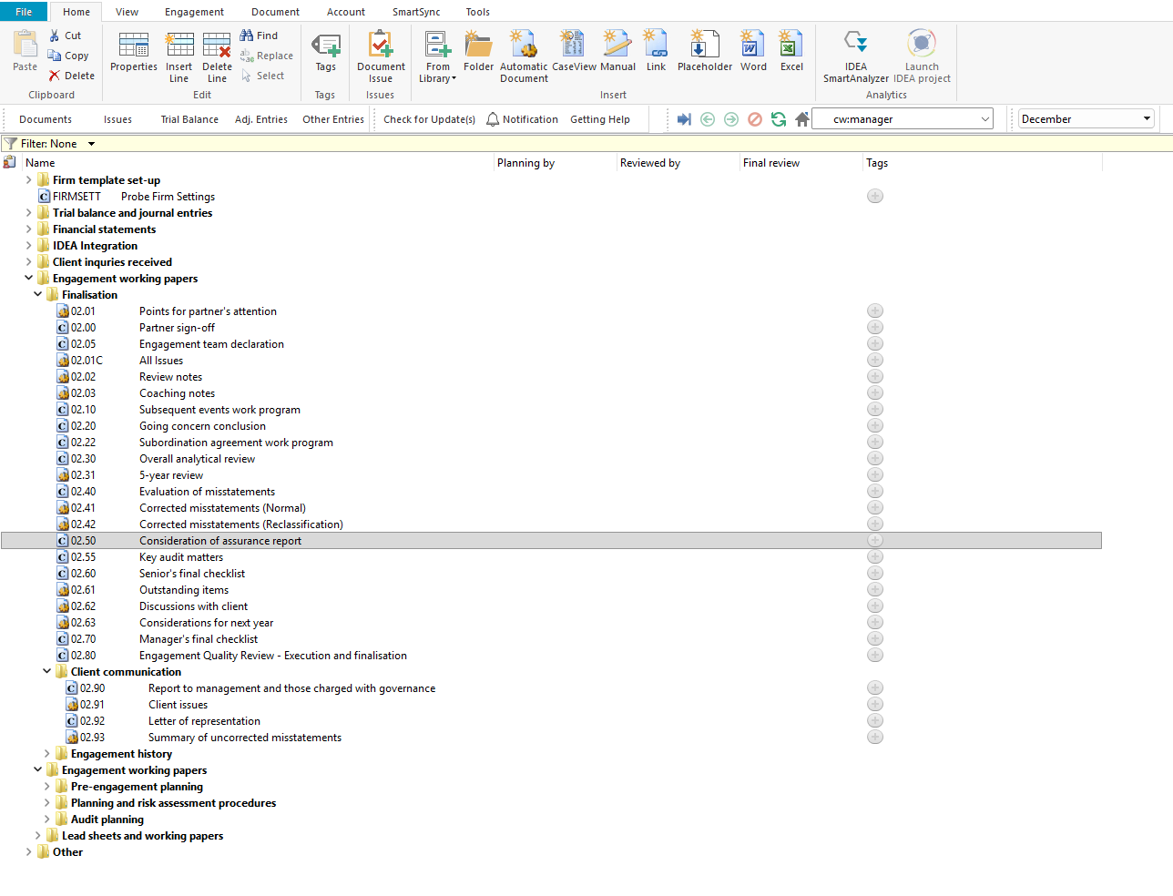

Document content

This document is designed to be a questionnaire type document with space for a comment or further description. The document contains 15 qualifying questions that determine the type of audit opinion to be expressed, followed by a detailed checklist for reviewing the draft audit report and evaluating key audit matters.

The document addresses the requirements of ISA 700 – Forming an Opinion and Reporting on Financial Statements and ISA 701 – Communicating Key Audit Matters in the Independent Auditor's Report. The following bookmarks are available in the document map to assist you in navigating the document:

Qualifying questions

Consideration of report

Key audit matters
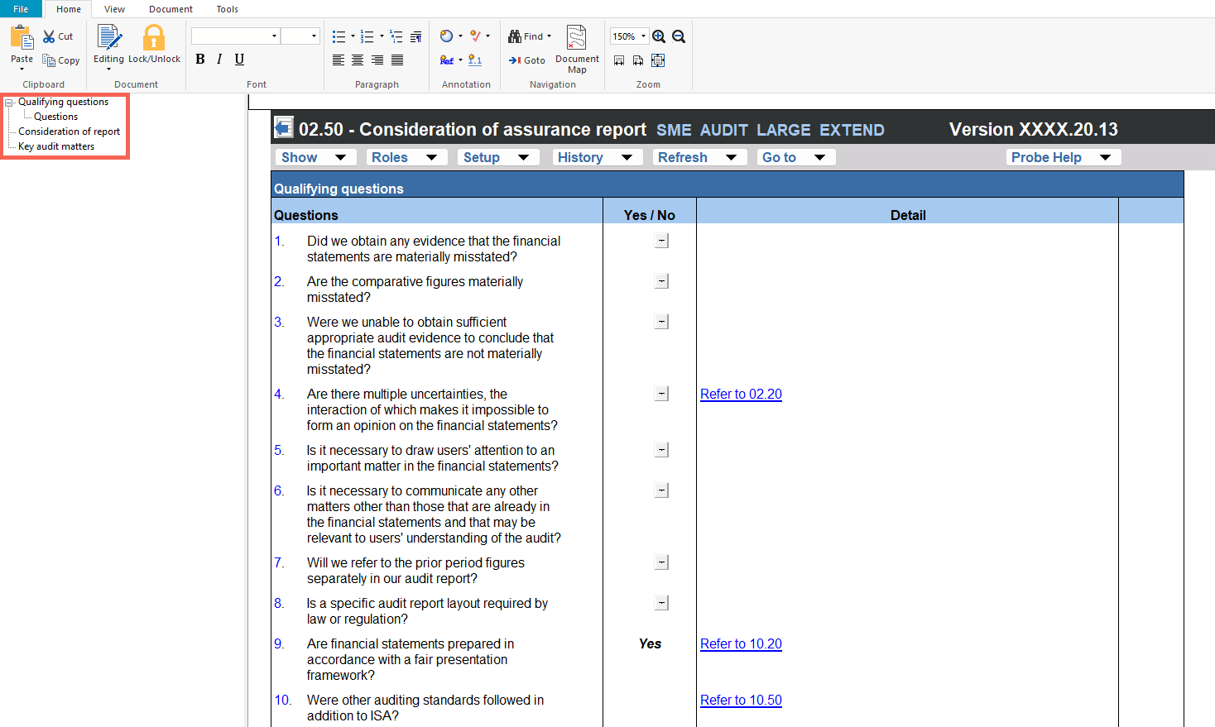

Layout
Column | Input Required | Outcome
Qualifying questions
Questions | No input is required in this column. Displays 15 pre-populated qualifying questions addressing material misstatement, comparative figures, sufficiency of audit evidence, multiple uncertainties, emphasis of matter, other matter, prior period figures, specific report layout, fair presentation framework, other auditing standards, reportable irregularities, public interest entity status, key audit matters, going concern, and material uncertainty. | No impact on the engagement file. Identifies the qualifying questions that determine the type of audit opinion to be expressed.
Yes / No | Select 'Yes' or 'No' for each qualifying question. | The audit opinion type is automatically determined based on the combination of answers to the qualifying questions. The resulting opinion is displayed below the qualifying questions.
Detail | Enter additional detail or explanation for each qualifying question where applicable. | No impact on the engagement file. Documents the engagement team's reasoning for each qualifying question response.
Consideration of report
Questions | No input is required in this column. Displays pre-populated checklist items for reviewing the draft audit report. The checklist covers the report title, addressee, opinion section, basis for opinion, responsibilities of the director, auditor's responsibilities, ethical requirements, other legal and regulatory requirements, audit tenure, and report dating, with references to the applicable ISA 700 paragraphs. | No impact on the engagement file. Provides the review framework for the engagement team to verify the audit report content against ISA 700 requirements.
Exceptions | Enter any exceptions or findings identified during the review of the draft audit report for each checklist item. | No impact on the engagement file. Documents the exceptions identified for the engagement file.
Initials and date | Enter the name or initials of the engagement team member who reviewed each checklist item and the date of review. | No impact on the engagement file. Records who reviewed each checklist item and when the review was performed.
Ref. | Enter a cross-reference to the relevant working paper or supporting documentation for each checklist item. | No impact on the engagement file. Documents the cross-reference for the engagement file.
Key audit matters
Questions | No input is required in this column. Displays pre-populated checklist items for reviewing the Key Audit Matters section of the audit report, including the introduction, subheadings, references to disclosures, and the description of each key audit matter, with references to the applicable ISA 701 paragraphs. | No impact on the engagement file. Provides the review framework for the engagement team to verify the Key Audit Matters content against ISA 701 requirements.
Exceptions | Enter any exceptions or findings identified during the review of the Key Audit Matters section for each checklist item. | No impact on the engagement file. Documents the exceptions identified for the engagement file.
Initials and date | Enter the name or initials of the engagement team member who reviewed each checklist item and the date of review. | No impact on the engagement file. Records who reviewed each checklist item and when the review was performed.
Ref. | Enter a cross-reference to the relevant working paper or supporting documentation for each checklist item. | No impact on the engagement file. Documents the cross-reference for the engagement file.

Document outcomes

The engagement team must answer the 15 qualifying questions to determine the type of audit opinion to be expressed. The opinion type is automatically determined based on the combination of answers and is displayed below the qualifying questions.

The engagement team must review the draft audit report against the checklist items in the consideration of report section, documenting any exceptions, the person who performed the review, and cross-references to supporting documentation. The checklist covers all required elements of the audit report in accordance with ISA 700.

The engagement team must review the Key Audit Matters section of the audit report against the checklist items, documenting any exceptions, the person who performed the review, and cross-references to supporting documentation. The checklist covers the required elements of the Key Audit Matters section in accordance with ISA 701.

Group Audits

When the engagement type was selected as 'Group Audit Single' or 'Group Audit Multiple', the consideration of assurance report applies to the group engagement. The engagement team must evaluate the audit opinion for the group financial statements and ensure the audit report reflects the group audit requirements, including references to component auditors where applicable.

IN CONCLUSION

Features

The following features are available in the document:

Insert or delete a comment, see page F3

Guidance, see page F16

Freeze, see page F19

